Team B

Week 7

Documentation

# 

**Reference documents** **1**

Customer Front side instructions (CANDY) 1

Admin (JENNIFER) 6

**Procedure manuals** **12**

Admin (Michael Kern) 12

Administrative Procedure Manual 12

Creating an Admin account 12

Accounts 13

Create a New Account 13

Export Accounts 13

Catalogs 13

Create New Item to Catalog 14

Export Catalog 14

Orders 14

Create New Order 14

Export Orders 14

Change status of the order 15

Users 15

Edit user information 15

Place an order for the user 16

Customer (Roman) 16

**Tutorials (Roman)** **20**

Payment Type 20

# 

# 

# **Reference documents**

## Customer Front side instructions (CANDY)

* + Register an account

1. Go to <http://devry-wsc.herokuapp.com>
2. Click on Sign up in the top right menu as shown below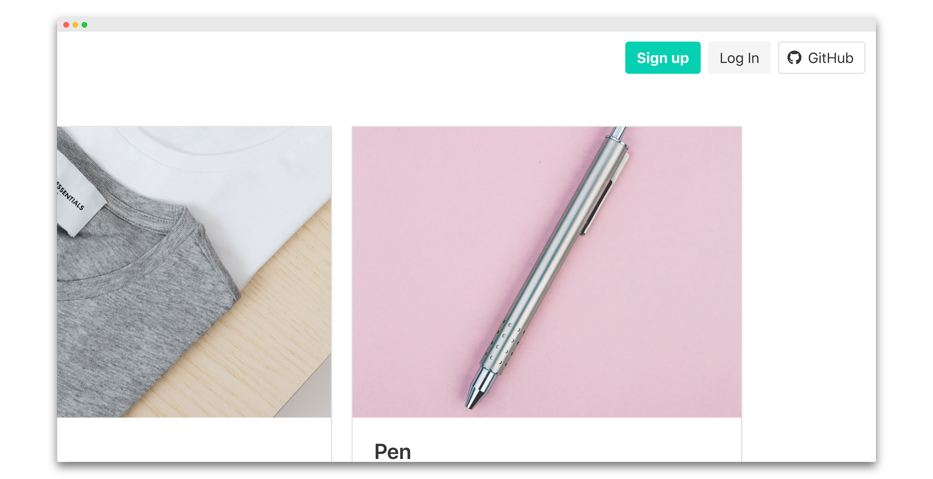
3. Enter the email you wish to register with.
4. Create a password.
5. Confirm Password.
6. Click the login button.

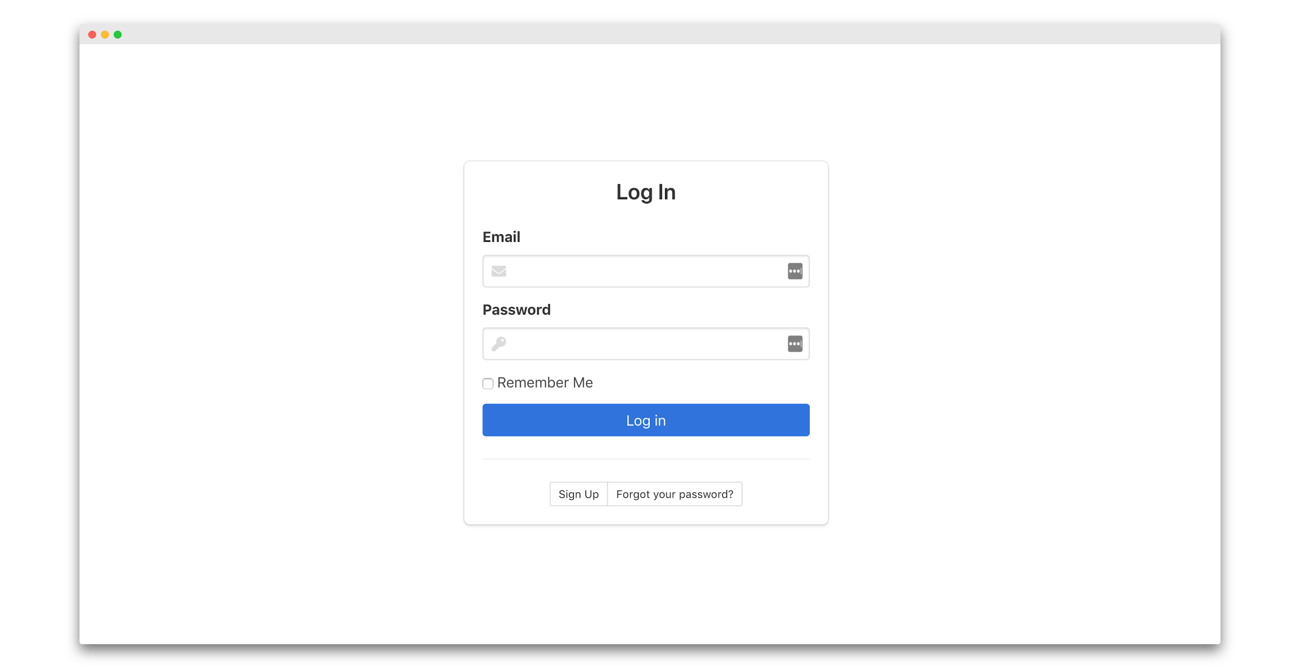

Congratulations you’ve registered a new account!

* + Adding personal information to account

1. Once you’ve created your account as shown above. Click on My Account.

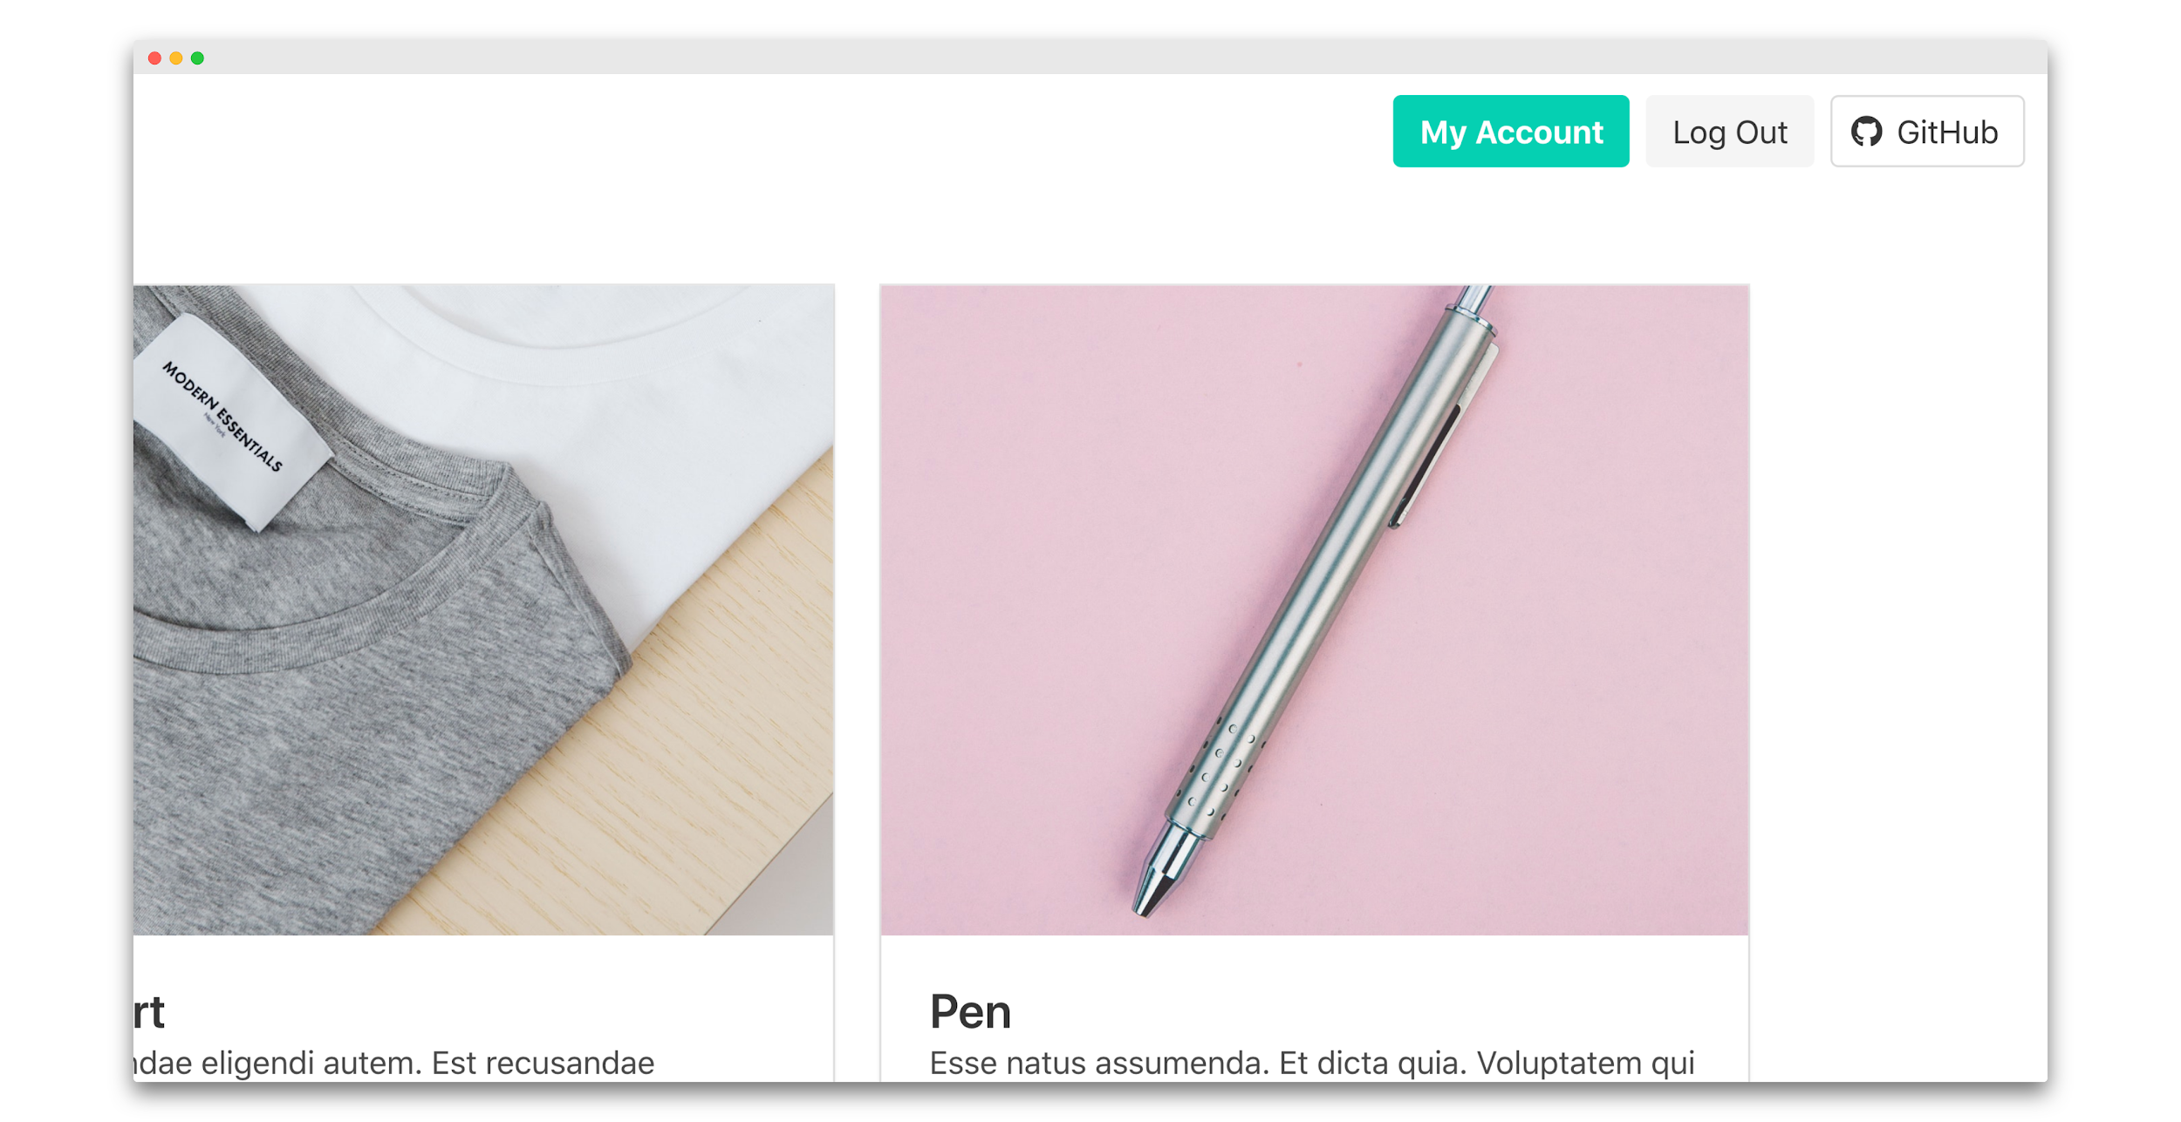

2. You will be redirected to your account. Click on the settings tab

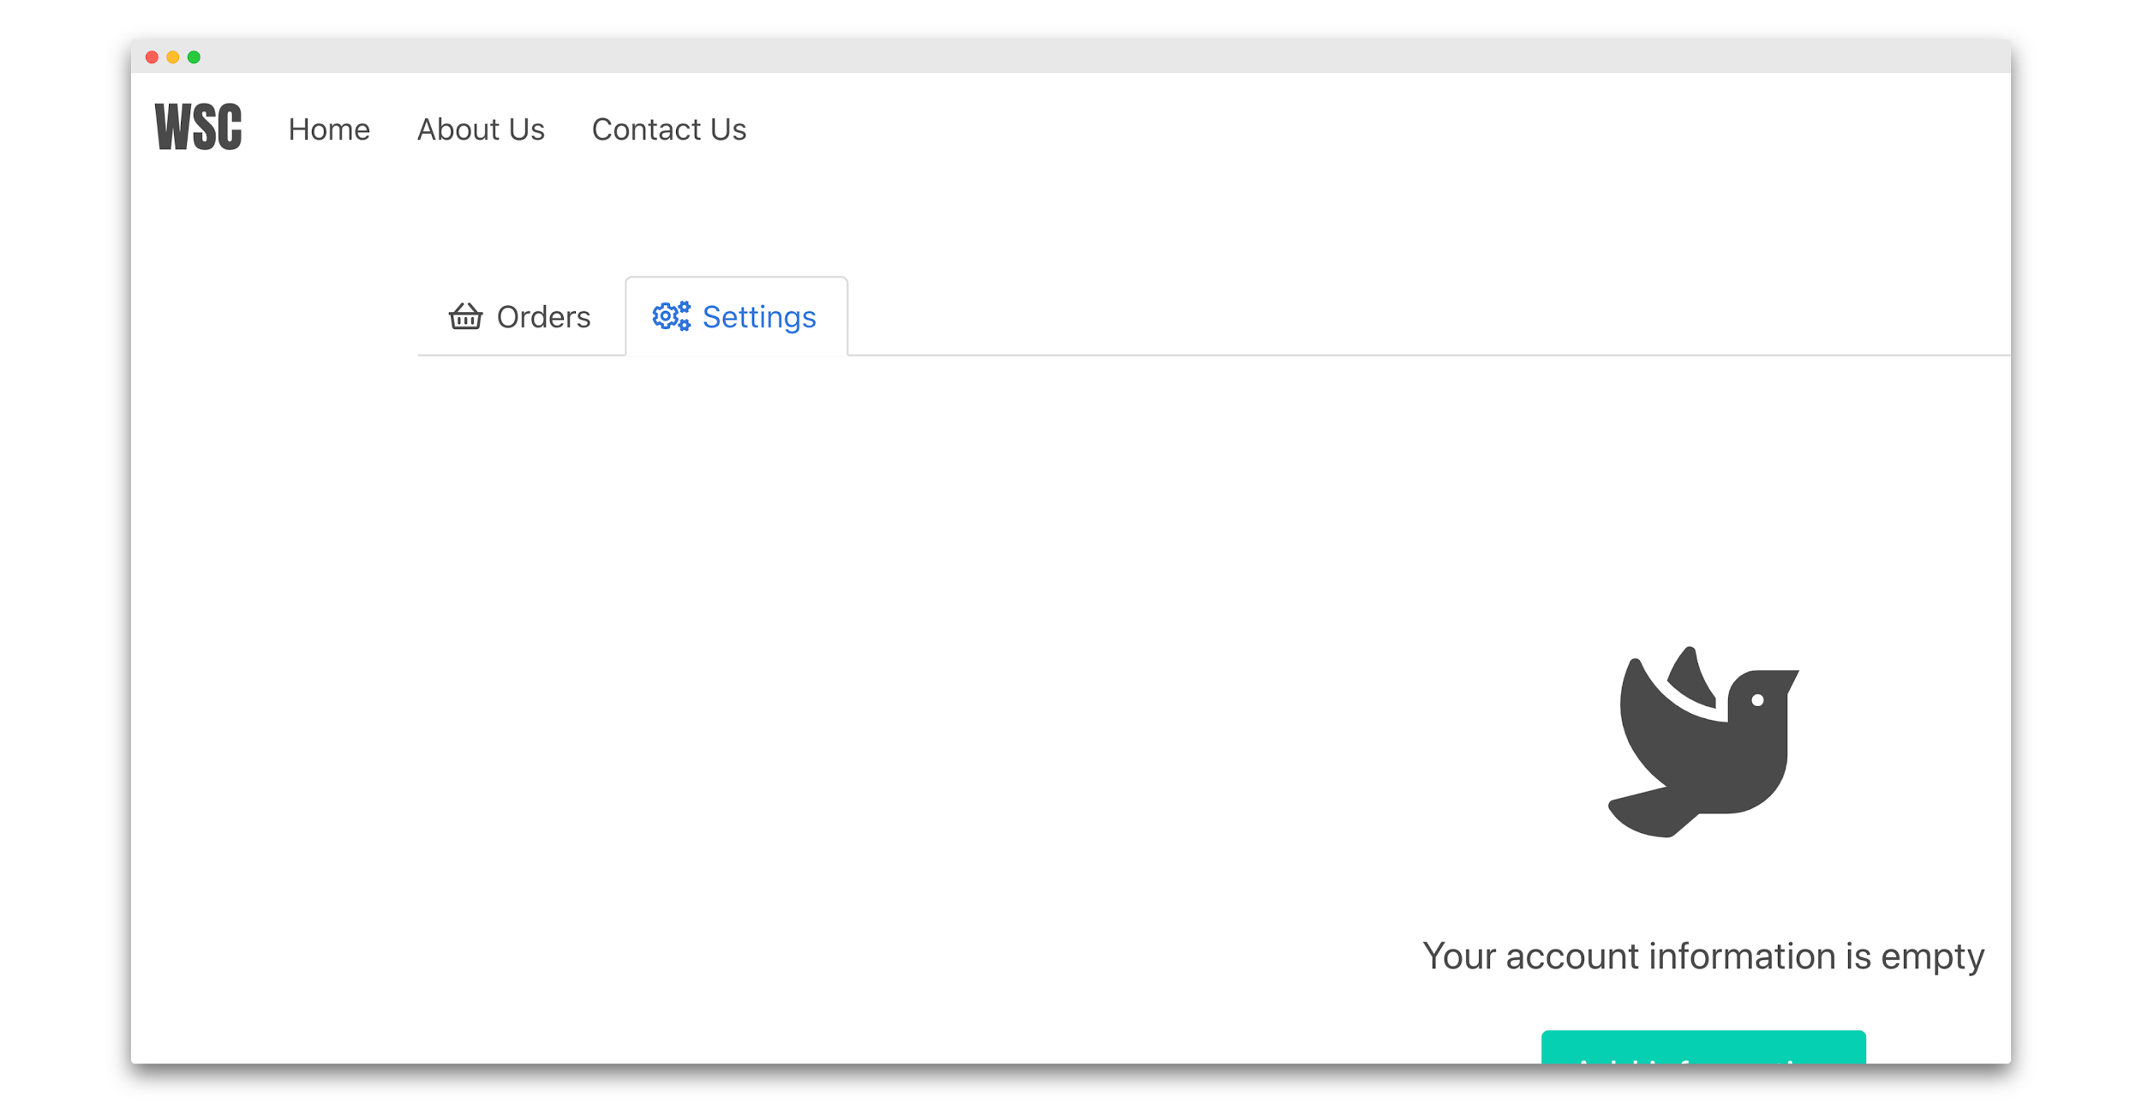

3. Once in the settings tab click on add information button.

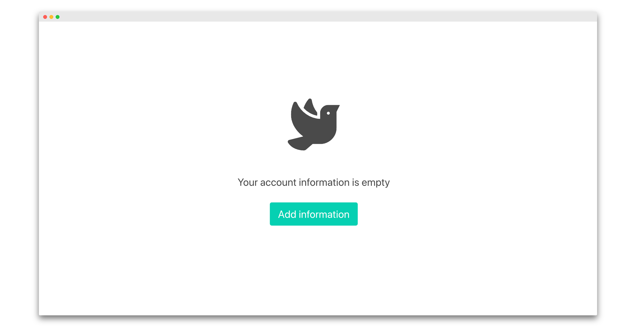

4. Fill out the information and click on the update button when done.

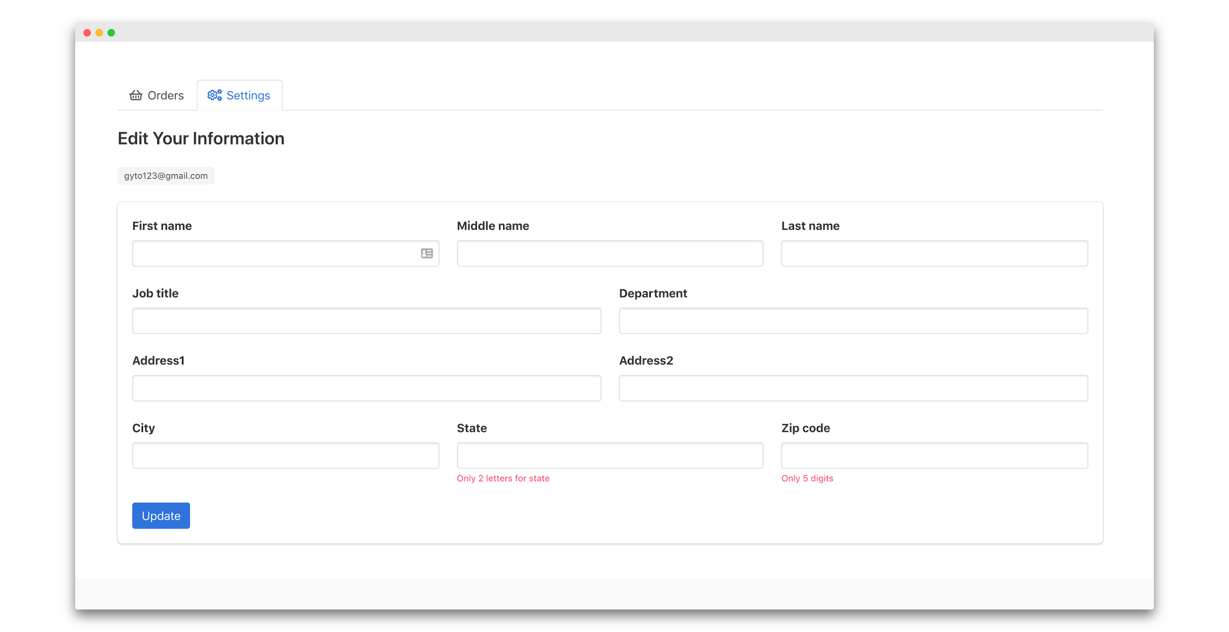

* + Manage orders

1. To manage your orders Sign into your account by going to <http://devry-wsc.herokuapp.com/login>
2. Input your login information and click on the login button when done.



3. Once logged in click on my account on the top right.

4. Select the order tab as shown below to see and manage your orders.

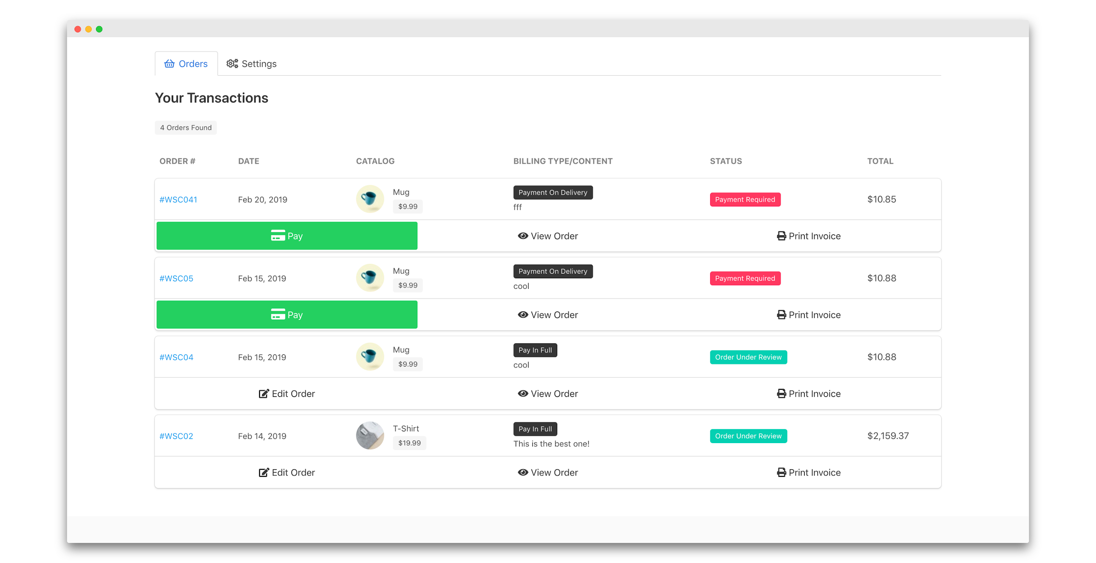

* + Ordering the catalog product

1. Once in the app <http://devry-wsc.herokuapp.com> Make sure you are signed in your account.
2. select the product you wish to order.
3. Select the Print Type and Billing Type.
4. Fill out the remaining information and submit the request.

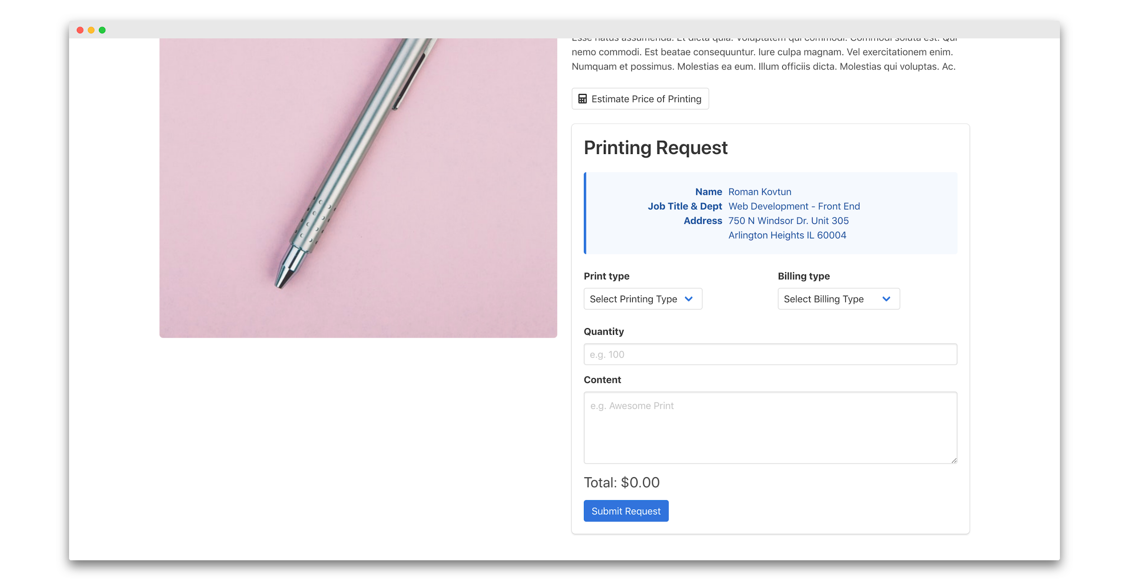

* + Contacting Support team if needed (contact-us)

1. To contact us simply select Contact us in the top left menu
2. Or go to <http://devry-wsc.herokuapp.com/contact-us>
3. Fill out your name, email, and comment, then press submit.

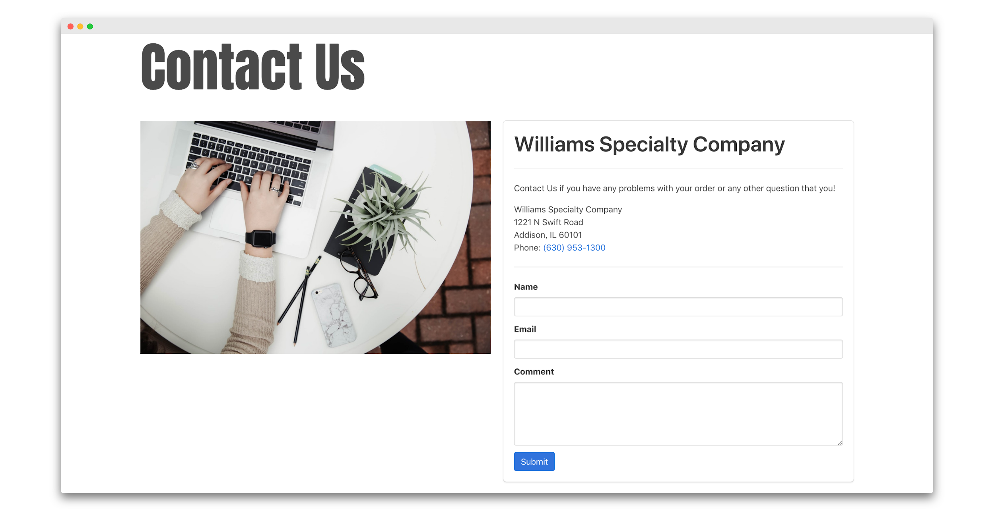

## Admin (JENNIFER)

Reference Document - [Admin Steps - https://drive.google.com/file/d/1zv49r67ZzydaX5fDnIeLutoZ6hEjlwMA/view?usp=sharing](https://drive.google.com/file/d/1zv49r67ZzydaX5fDnIeLutoZ6hEjlwMA/view?usp=sharing)

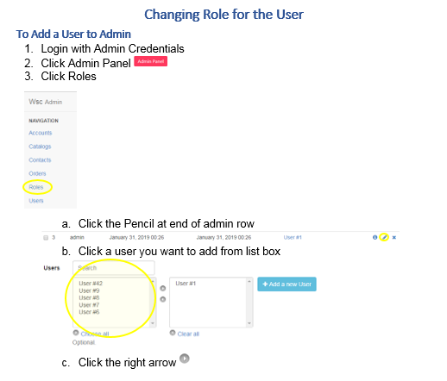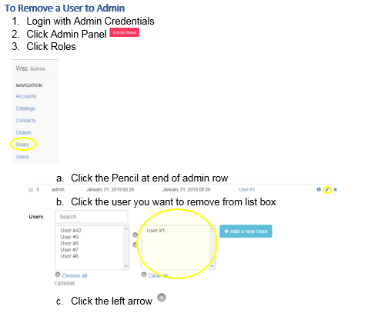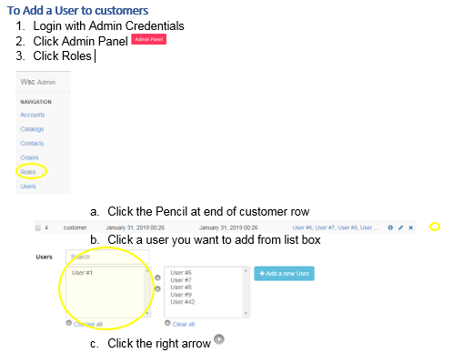

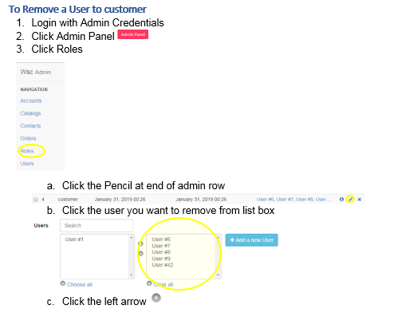

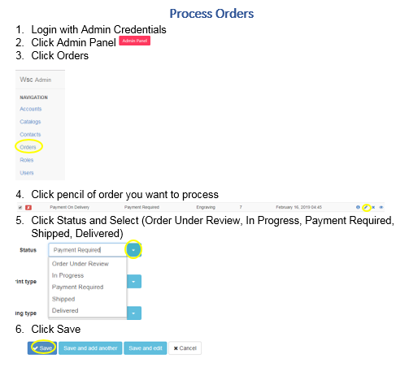

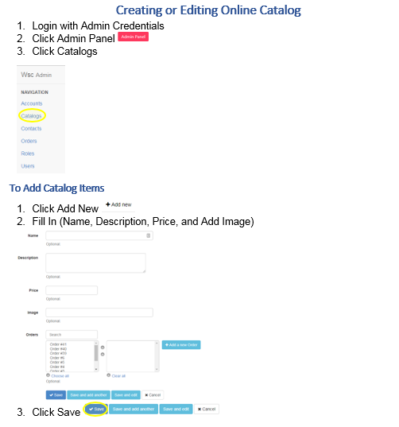

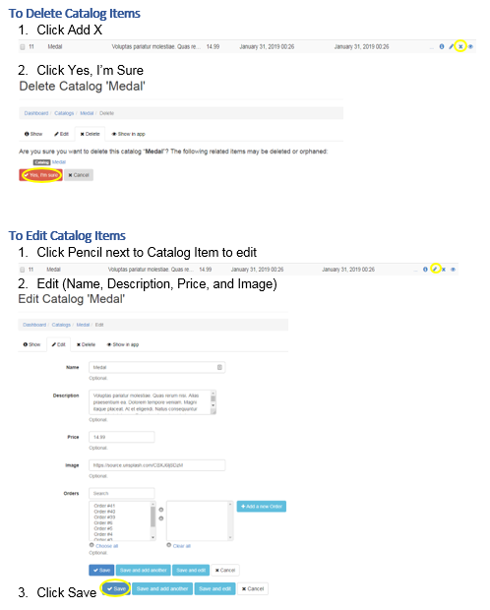

# **Procedure manuals**

## Admin (Michael Kern)

### Administrative Procedure Manual

The default login page will be used to create admin accounts: <http://devry-wsc.herokuapp.com/login>

Currently, the only admin account is listed below

Email: [gyto23@gmail.com](mailto:gyto23@gmail.com)  
Password: password

Once you log into the site the admin panel will be a button at the top of the screen in red:

Selecting the Admin Panel will take you to the site administration page:

There are 6 pages that link from here for administrative controls: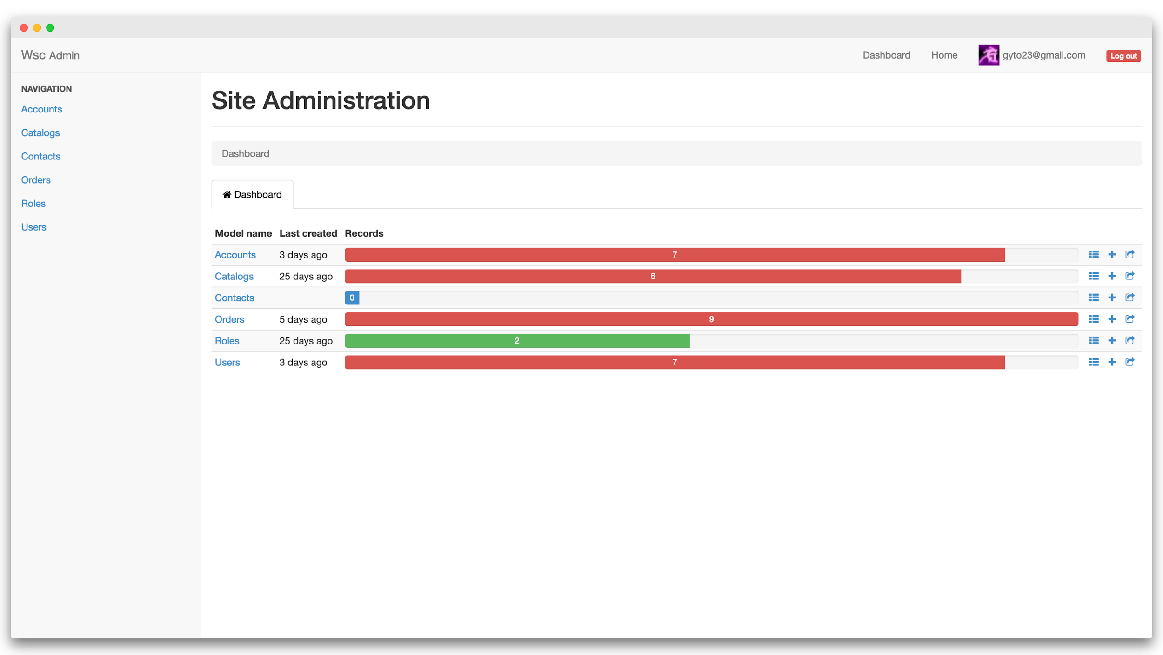

1. Accounts
2. Catalogs
3. Contacts
4. Orders
5. Roles
6. Users

### Creating an Admin account

1. Create a new account on <http://devry-wsc.herokuapp.com/login>
2. Login as admin and select admin panel
3. Select ‘Accounts’ in the navigation page from the admin panel
4. Locate the account you wish to receive admin permissions
5. Select edit account 
6. This will bring you to account edit page, select edit user
7. Select ‘Admin’ checkbox 
8. New account now has administrative privileges

### Accounts

1. From Admin Panel select ‘Accounts’ from the navigation bar on left
2. Accounts page will display every account the website holds with the following information:
   1. ID
   2. First Name
   3. Last Name
   4. Middle Name
   5. Address1
   6. Address2

#### **Create a New Account**

1. From Account page select ‘Add new’ tab 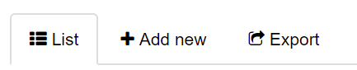
2. Fill out account information select 

#### **Export Accounts**

1. Select the Export tab
2. Select fields you want to export
3. Choose to encode from the drop-down menu
4. Choose column separator from the drop-down menu
5. Export to the selected file format

### Catalogs

1. Select ‘Catalogs’ from the navigation bar
2. Information displayed
   1. ID
   2. Name
   3. Description
   4. Price
   5. Created at timestamp
   6. Updated at timestamp

#### **Create New Item to Catalog**

1. From catalog page select ‘Add new’ tab 
2. Fill out account information select 

#### **Export Catalog**

1. Select the Export tab
2. Select fields you want to export
3. Choose to encode from the drop-down menu
4. Choose column separator from the menu
5. Export to the selected file format

### Orders

1. From the Admin Panel select Orders from the navigation bar
2. The information from all orders is displayed here and includes:
   1. Paid ‘Status’
   2. Billing type
   3. Status
   4. Print type
   5. Catalog ‘Number’
   6. Order date

#### **Create New Order**

1. From Orders page select ‘Add new’ tab 
2. Fill out account information select save

#### **Export Orders**

1. Select the Export tab
2. Select fields you want to export
3. Choose to encode from the drop-down menu
4. Choose column separator from the drop-down menu
5. Export to the selected file format

#### **Change status of the order**

1. From order page select the order you want to change
2. Select the edit button
3. Editable information includes:
4. Status
5. Print type
6. Billing type
7. User number
8. Catalog number

4. Click save

### Users

1. From the admin panel select ‘Users’ from the navigation bar

#### **Edit user information**

1. From the list of users, page locate the user to be edited
2. Select the edit button
3. Editable information:
   1. Email
   2. Password
   3. Password confirmation
   4. Reset password set at the time
   5. Remember password created at
   6. Sign in count
   7. Last sign in at timestamp
   8. Last sign in IP address
   9. Admin checkbox
   10. Roles
   11. Orders
   12. Account number

4. Click save when finished with edits

#### **Place an order for the user**

1. Locate user within Users page within Admin Panel
2. Edit user that you are placing the order for 
3. Go to Orders section select 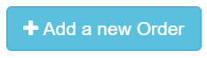
4. Fill out order information click save

## Customer (Roman)

1. Registering the account and ordering the catalog product and reviewing it in the account transaction section of the site. It has to describe how to preview the order, how to update the order, and how to print an order, in which case is PDF file preview of the invoice.
2. First, we registering an account as the user
3. After creating an account we going to add user information in order to process the order

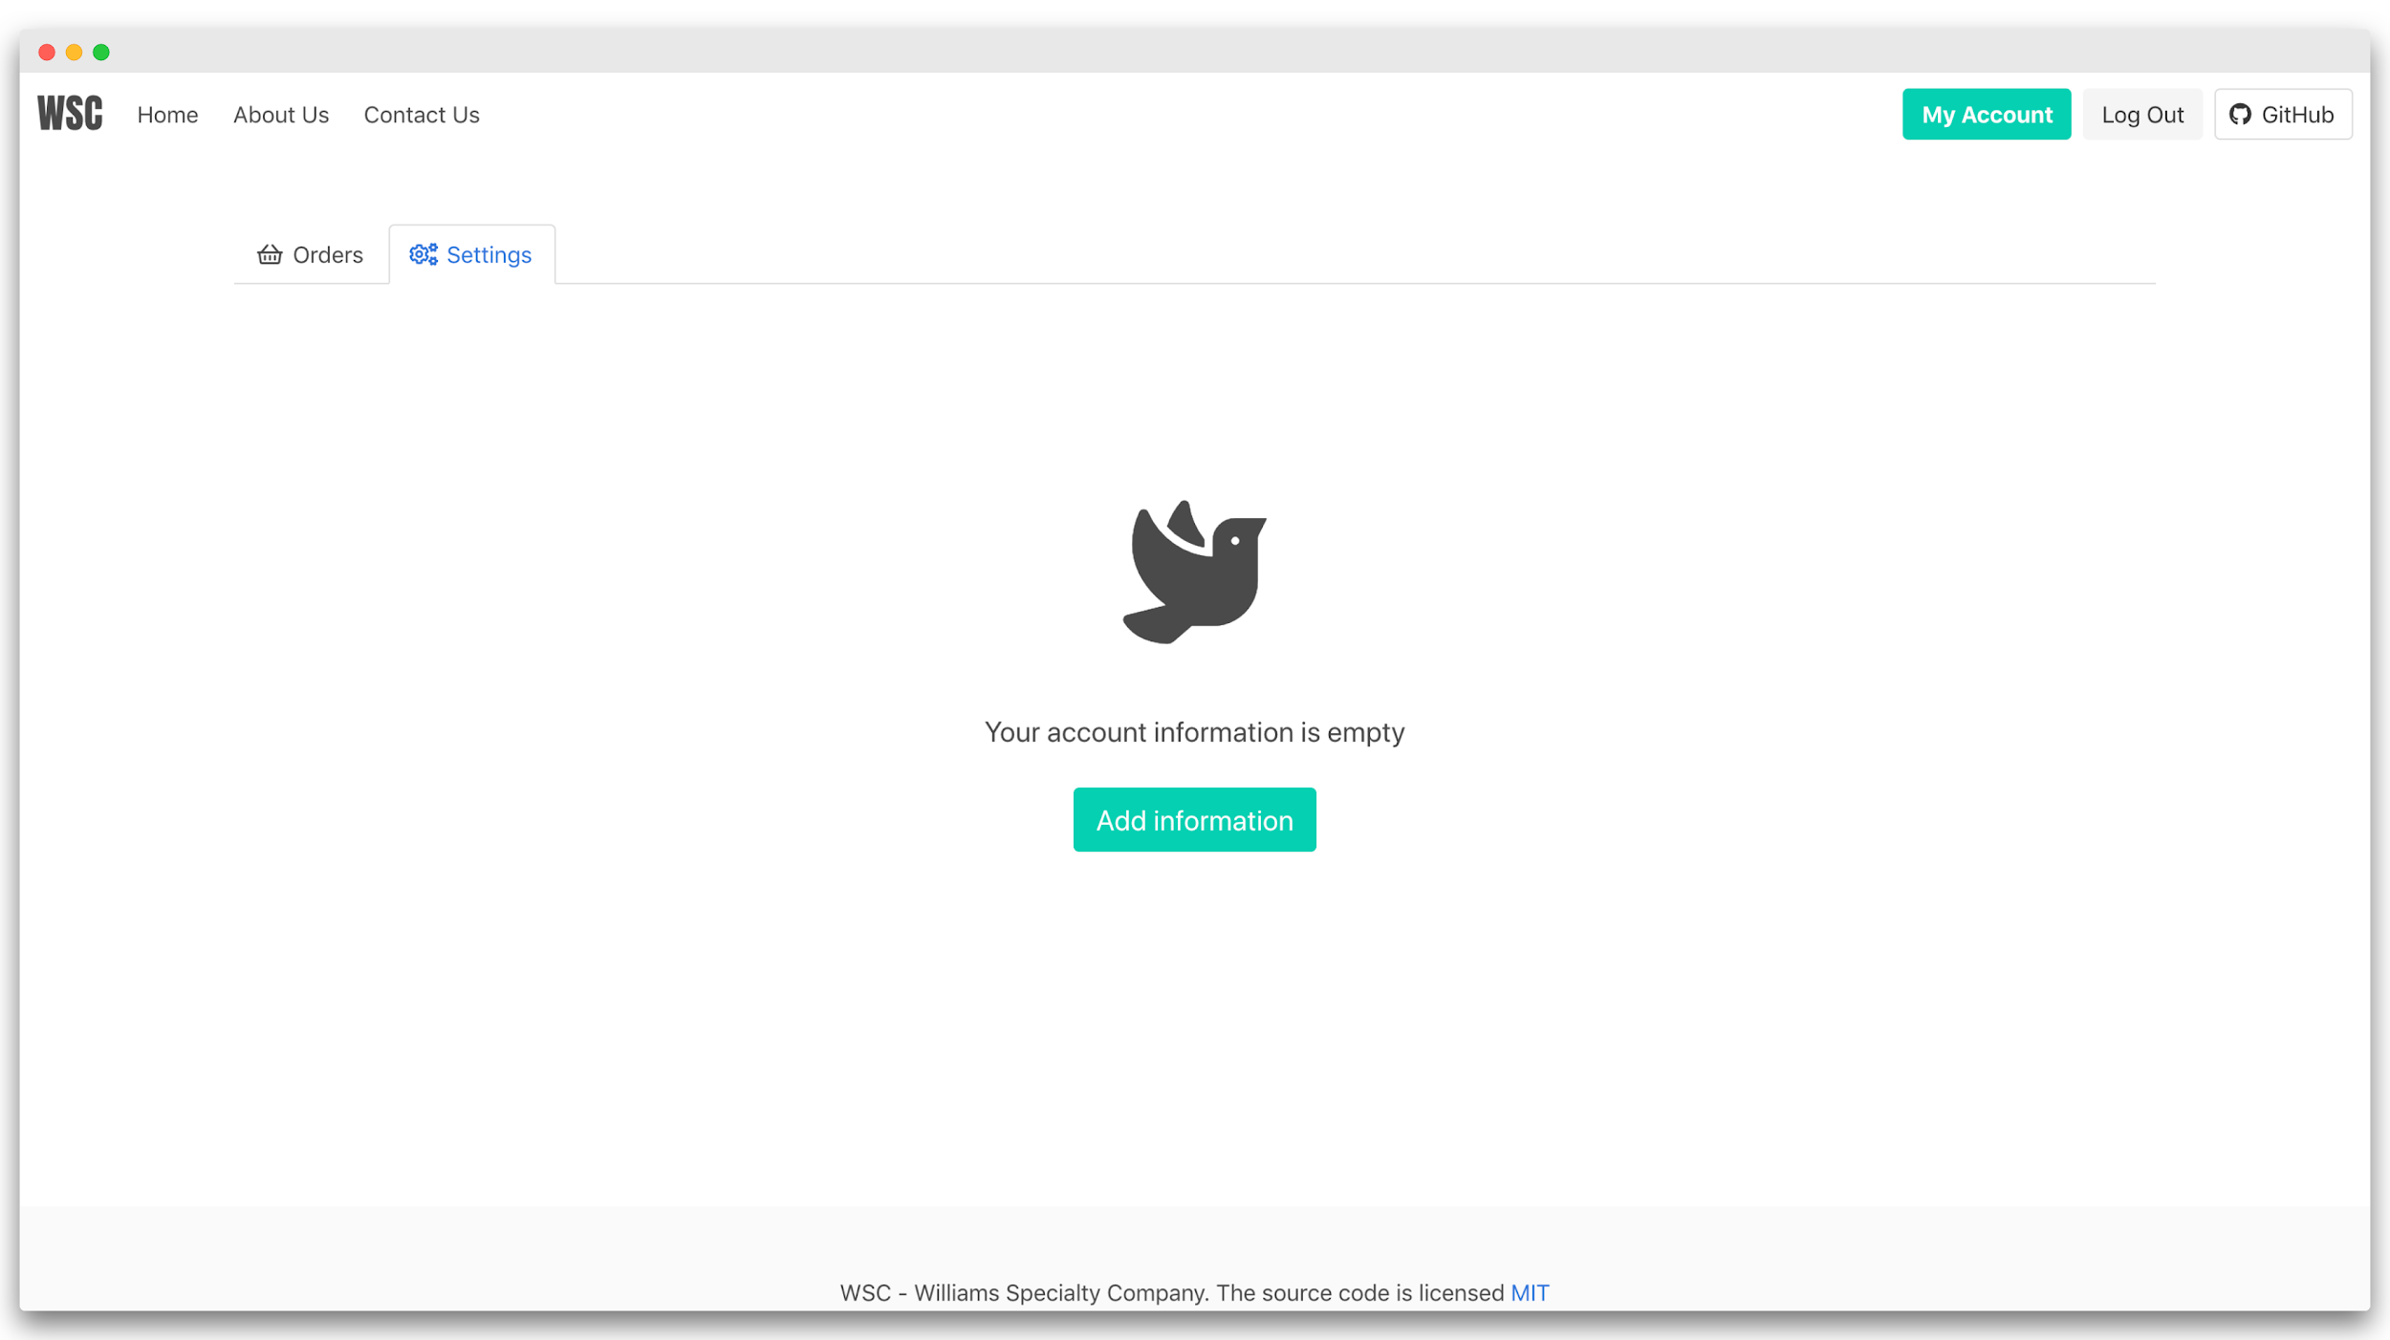



1. After filling out the content in the form we going to order the product

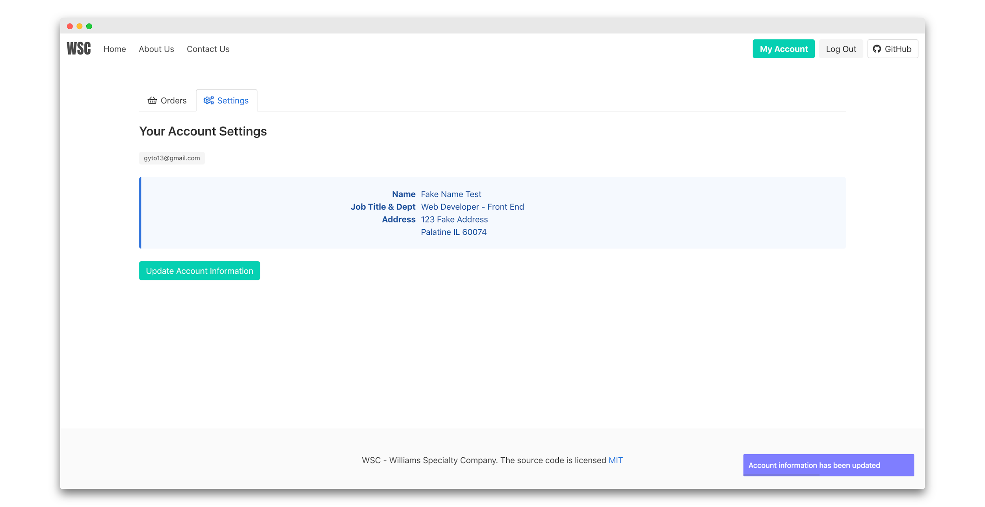

1. For example, we going to order a simple t-shirt and will write dummy content

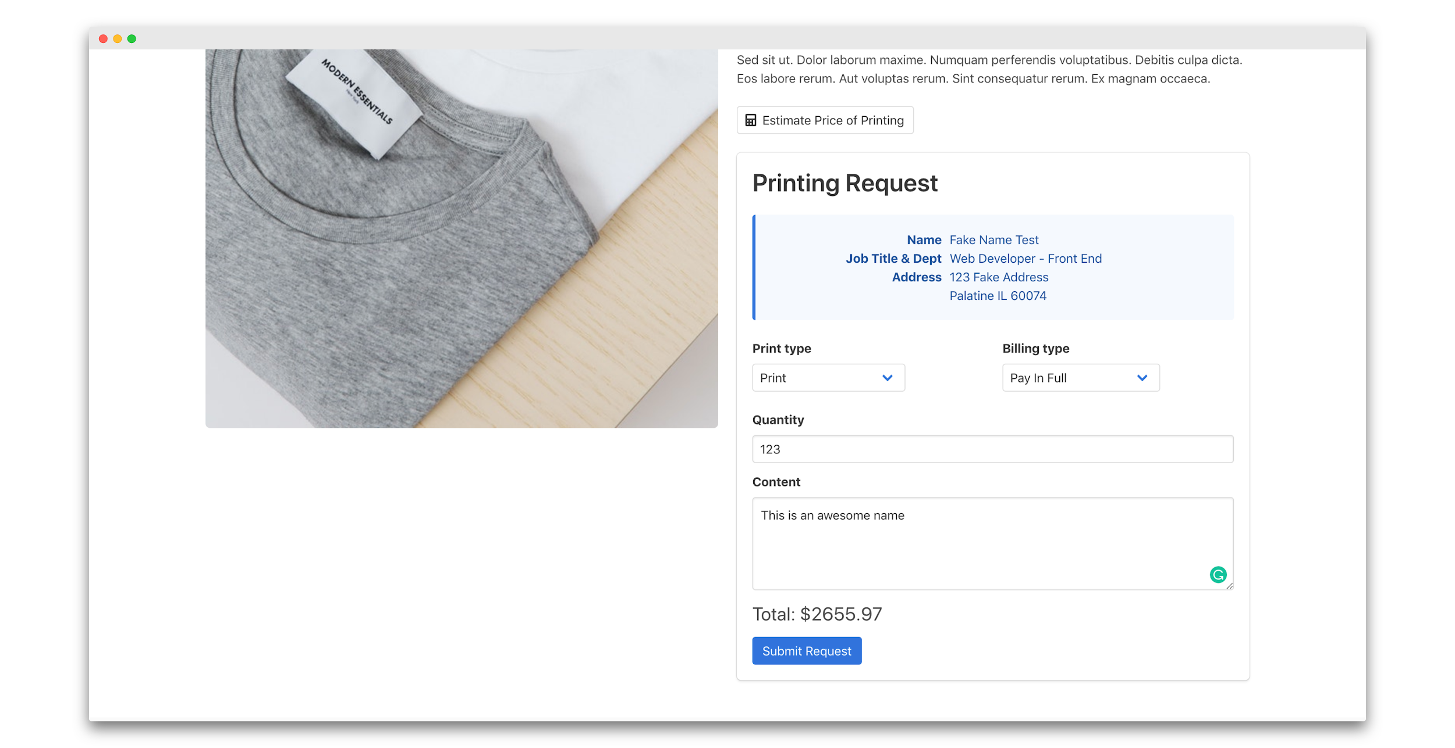

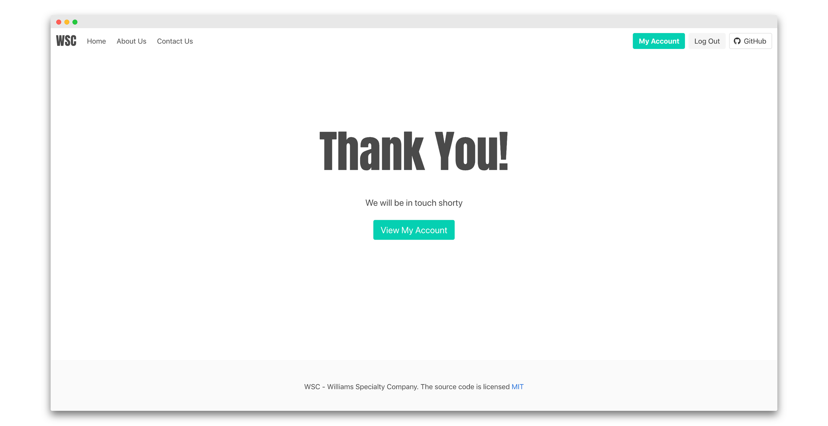

1. After successful order, we now can review the order in our account transaction tab

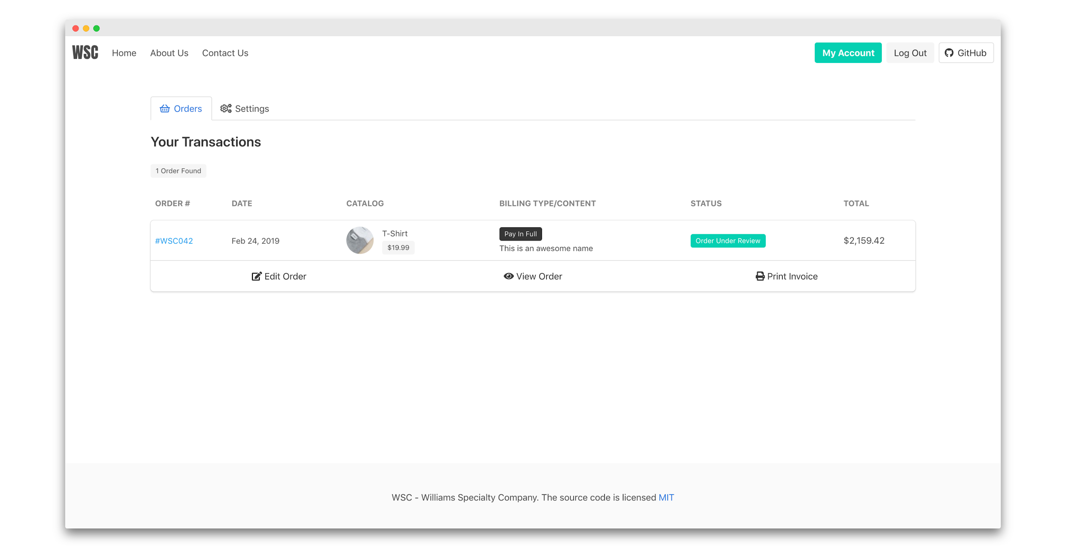

1. At the current stage, the order is waiting for a review from the printing company. We have a chance to edit the order as much we can until the Printing company decide to set the progress of the order to “In Progress”, which is not going to allow the customer to edit order any more.
2. If the customer decided to print the order invoice he/she can click on the “Print Invoice” button to preview the order invoice first and then print or save PDF file.

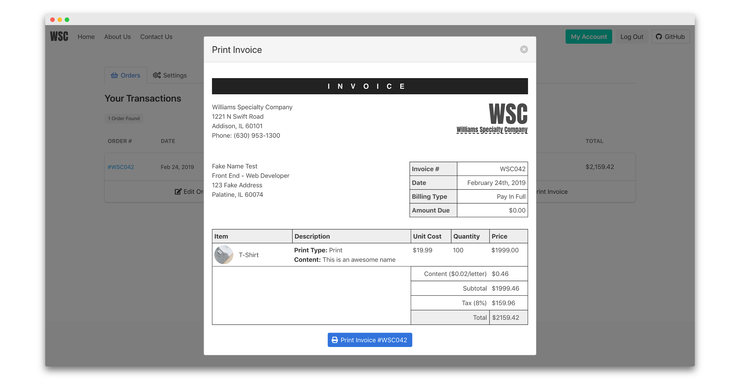

1. At that point, we can see how invoice is going to look like and decided if the customer has been charged with the right amount. In addition, if the customer has “Pay On Delivery” printing option. It will show how much customer has to pay for the order when it will arrive. If the order is “Paid in Full” then the order will not show the “Amount Due” price.

# **Tutorials (Roman)**

## Payment Type

* The difference of order payment type with Pay In Full and Payment on Delivery is procentage that applies to the “Payment on Delivery”. Which also requires user input to pay the 10% of the order on the beginning to be sure that order can be started before it printed.

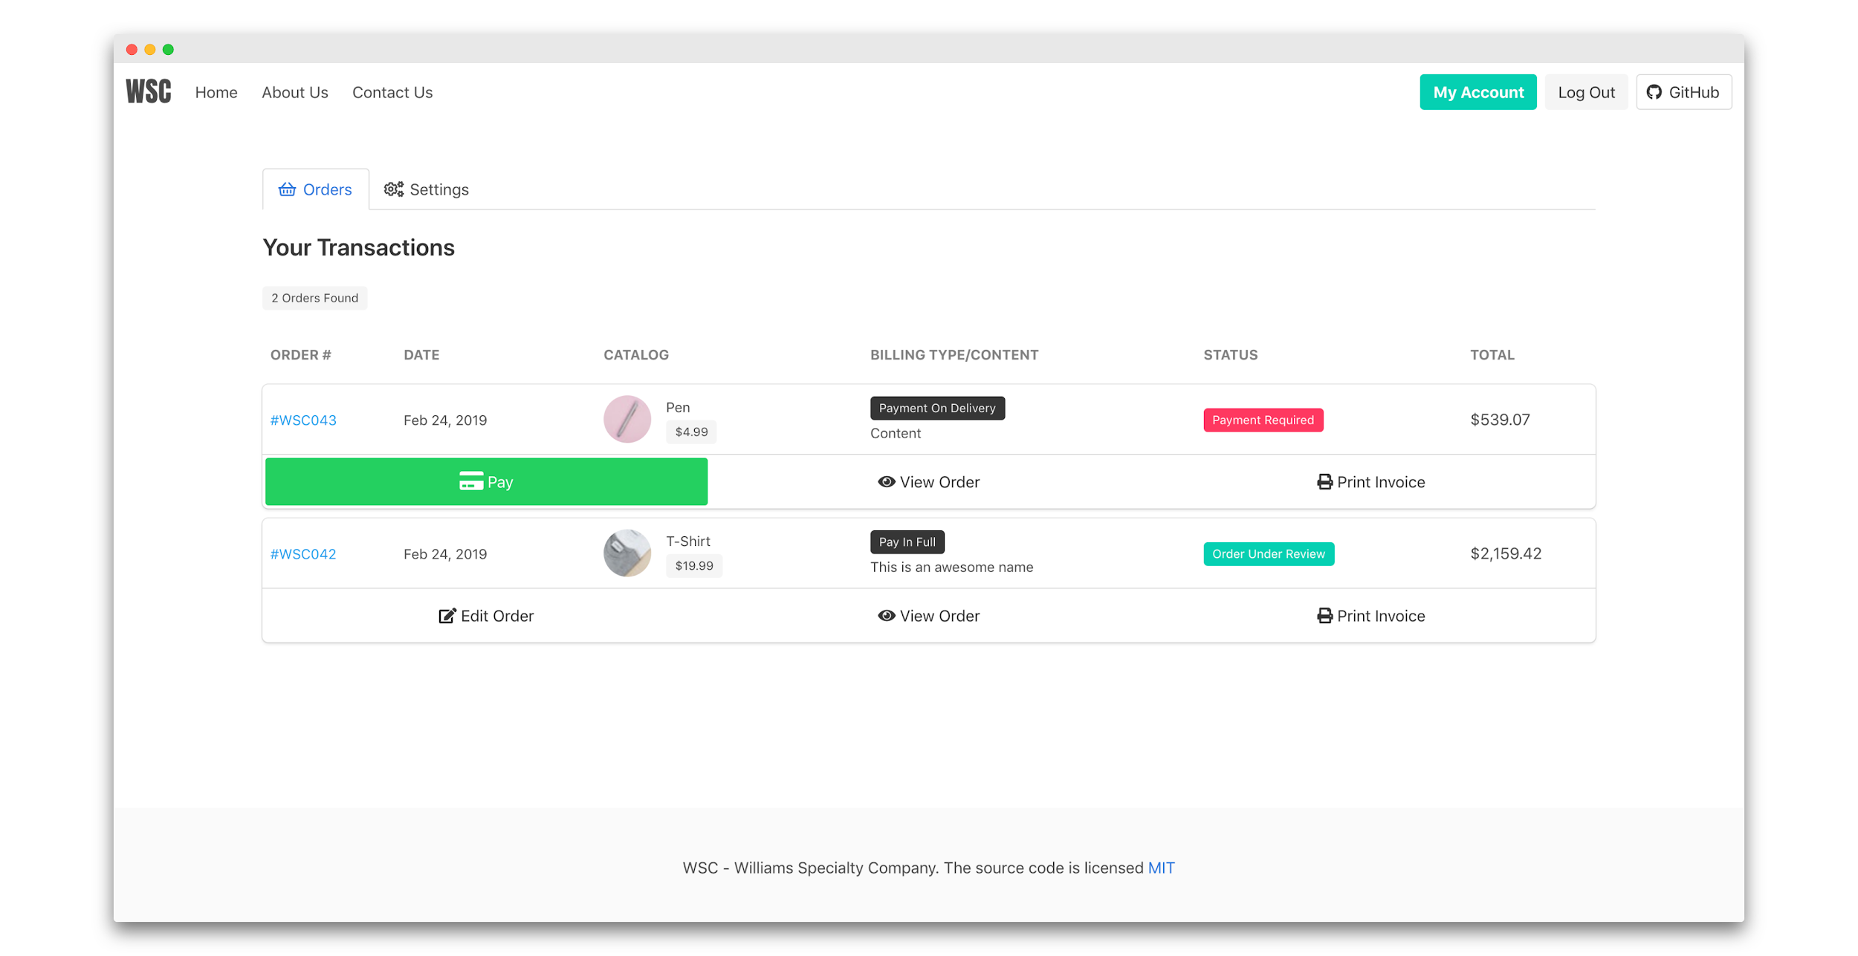

* If we take an example of two orders we can see clearly that customer has to pay for the first order first before printing company can start.
* As we can see below on the screenshots we can clearly see that “Amount to pay” requires the customer to pay. However, when it regular order that not.

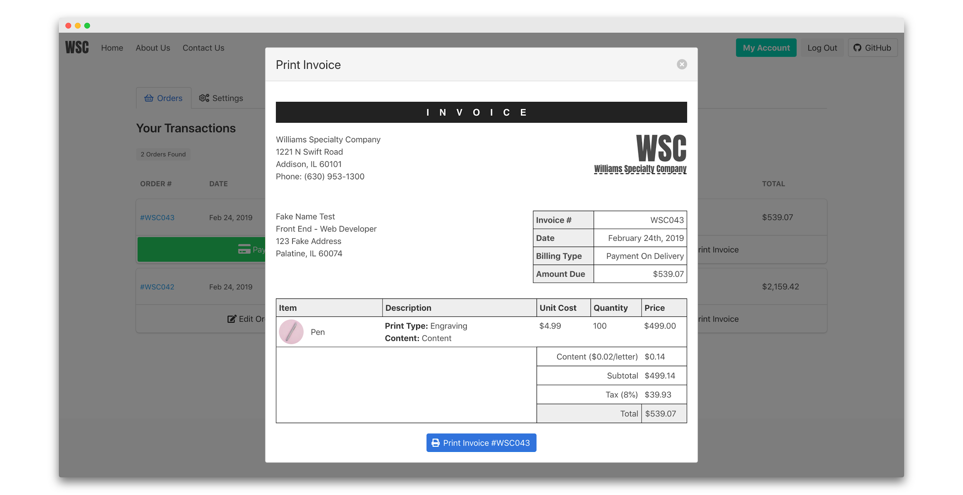



* In the case when the order can be paid by the customer. They can just click on the button to pay and then it will refresh status of the order “Order Under Review”, which means that user has a chance to pay 10% of the order and then wait for the order to be delivered too or change anything that customer need before printing company set the status to “in Progress”. The “Amount Due” still will on the order because it whatever left to pay that 90%.

